Chapter 8, Problem 43.

The switch in Fig. 8.91 is opened at t = 0 after the circuit has reached steady state. Choose R and C such that α = 8 Np/s and ω_{d} = 30 rad/s.

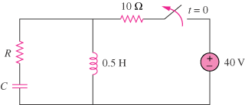

Figure 8.91
For Prob. 8.43.

